**Title**

Comparative Analysis of TCP and UDP Protocols’ Performance in Simulated Network Conditions

**Summary**

This report conducts a comprehensive comparative analysis of the Transmission Control Protocol (TCP) and User Datagram Protocol (UDP) focusing on key performance metrics such as delay, throughput, and packet drops within a simulated network environment on Ubuntu.

The results indicate that across all tested performance metrics, TCP outperforms UDP in ensuring the reliability and integrity of data transmission. TCP demonstrates lower packet loss rates and more stable delay performance, making it particularly suitable for applications that demand high accuracy and reliability. In contrast, although UDP was originally designed to provide faster transmission speeds, it did not surpass TCP in any performance metrics during these experiments.

**Introduction**

In the field of network engineering, the deployment and management of network simulations are pivotal tools for the advancement and testing of network protocols and architectures. This study encompasses a detailed exploration of a simulated circular wireless network composed of ten nodes, where dynamic roles are assigned: 20% as sender nodes, another 20% as receiver nodes, and the remaining 60% operate as relay nodes. The nodes' roles, determined through a random selection process, play a crucial part in the network's overall data transmission strategy, with distinct protocols—TCP (Transmission Control Protocol) for 10% of the sender-receiver pairs and UDP (User Datagram Protocol) for another 10%. By automating the simulation process using scripts, this method allows for consistent reproduction of test conditions, thereby minimizing variability in data and enhancing the reliability of results. This structured simulation and analysis approach aims to analyze the gap in temporal performance of TCP and UDP under randomly selected network conditions, providing a strong contrast to illustrate the properties of TCP and UDP.

**Proposed Work**  
The proposed work centers on a network simulation designed to meticulously evaluate the performance of two prominent transport layer protocols: TCP (Transmission Control Protocol) and UDP (User Datagram Protocol). The simulation constructs a circular wireless network topology consisting of at least ten nodes. These nodes are dynamically assigned specific roles with 20% functioning as sender nodes, another 20% as receivers, and the remaining 60% acting as relay nodes, which are essential for the continuity and efficiency of data transmission across the network.

The simulation's unique attribute involves the random selection of nodes for TCP and UDP communication. Specifically, 10% of the sender-receiver pairs are assigned to use TCP, and another 10% to use UDP. I randomly select node 9 and node 3 for UDP and node 4 and node 6 for TCP.

In terms of the simulation scenario, the network is simulated to operate continuously for 1000 seconds for each run, generating essential data files such as TRACE (.tr) and Network Animator (NAM) files (.nam). These files capture detailed information on every packet's journey through the network, providing insights into metrics like delay, throughput, and packet loss. This process is not only automated but also repeated 20 times to iron out any anomalies and to extract statistically significant results.

In detail, the working procedures are

Step1: Finish creating COMP1047CWP2-YouyaoGao-20516639-Q1.tcl , udp.awk and tcp.awk which can provide the output to a txt file

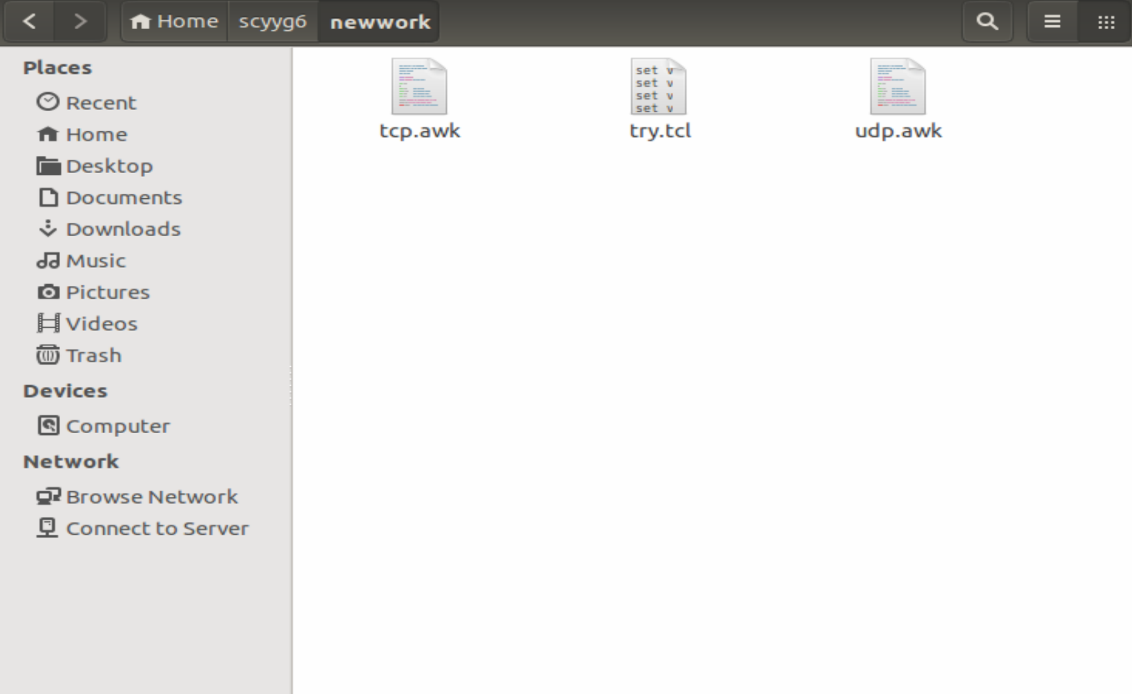

Step2: Run COMP1047CWP2-YouyaoGao-20516639-Q1.tcl in the terminal using the command ‘**ns COMP1047CWP2-YouyaoGao-20516639-Q1.tcl**’.

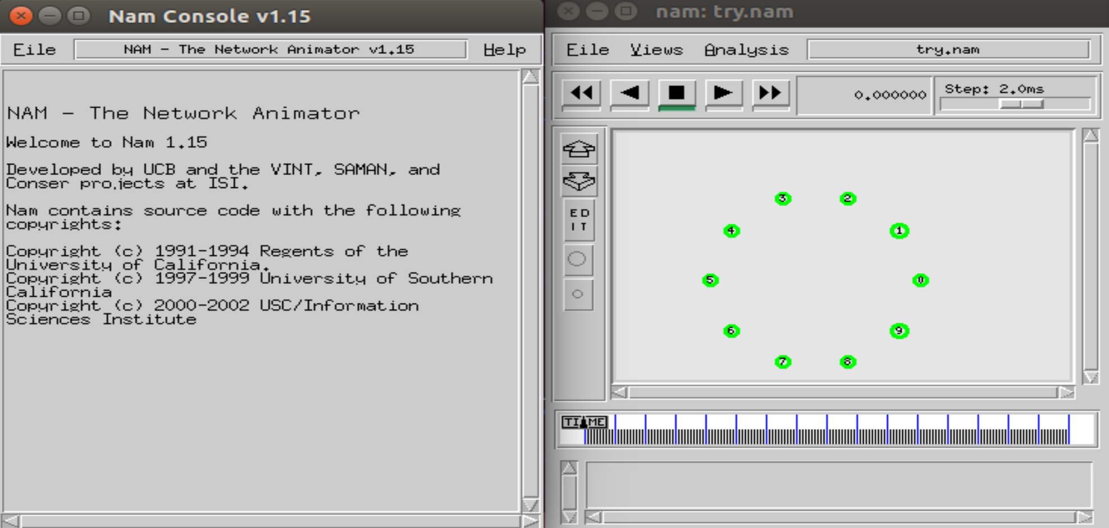

Step3: Run udp.awk using the command ‘**awk -f udp.awk try.tr**’

Step4: Run tcp.awk using the command ‘**awk -f tcp.awk try.tr**’



Step5: Find output0.txt and output1.txt and load them into Excel

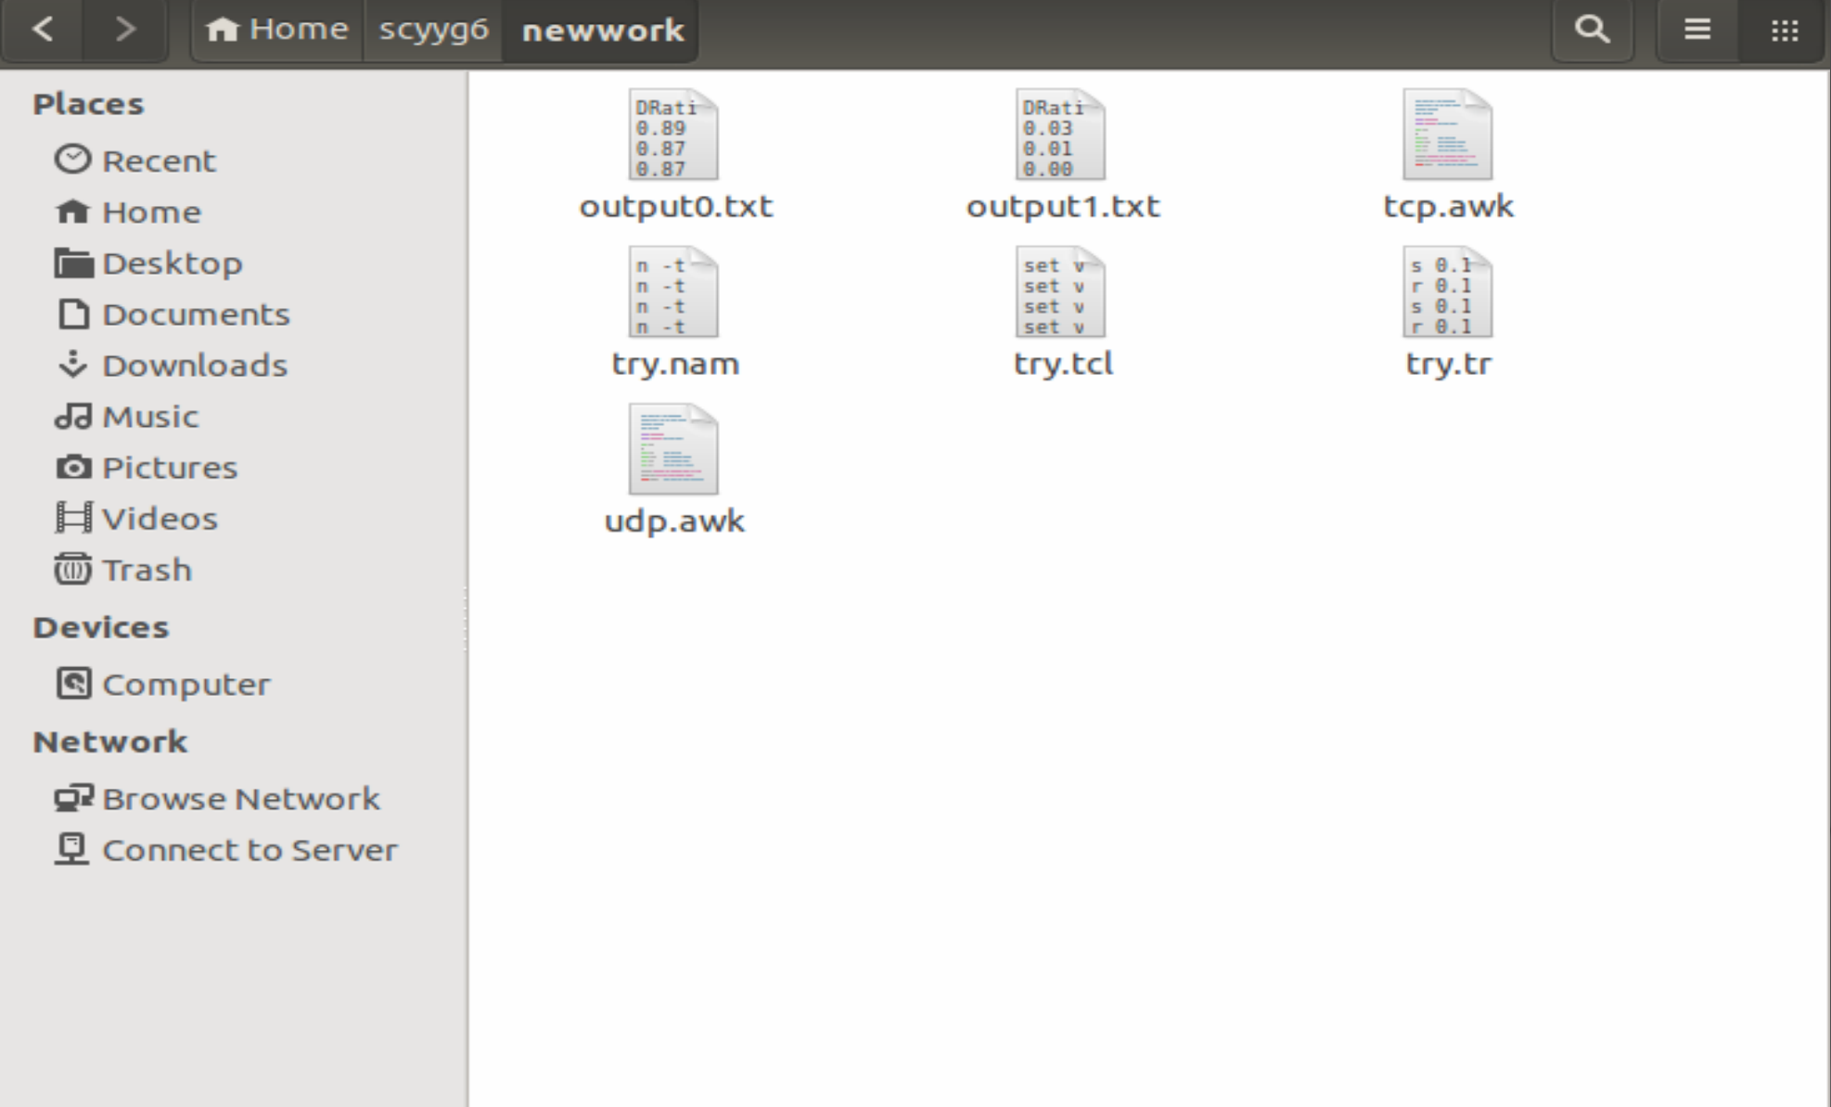

Step6: Repeat Step2 to Step5 for 20 times

Step7: Create the line chart according to the form of data in the Excel

**Results and Discussion**

First, explain the three graph.

From the first graph, we can observe the following: The blue line represents the packet drop ratio for UDP. It starts at a point just below 0.9% and shows a slight downward trend as time progresses. This indicates a small improvement in packet drop performance for UDP over the observed time period. The orange line represents the packet drop ratio for TCP, which appears to be relatively constant and significantly lower than UDP, maintaining a level close to 0.1% throughout the time period shown. This suggests that TCP consistently experiences far fewer packet drops compared to UDP.

From the second graph, we can observe the following: The blue line represents the delay for UDP. It starts at a high level of approximately 3000 ms and then shows a dramatic increase to about 7000 ms early in the timeframe. After this, the UDP delay remains relatively stable at this high level for the rest of the observed period. The orange line, which represents TCP delay, is flat and remains at a minimal level close to 0 ms throughout the entire duration of the time series displayed. This indicates that TCP experiences virtually no delay compared to UDP in this scenario.

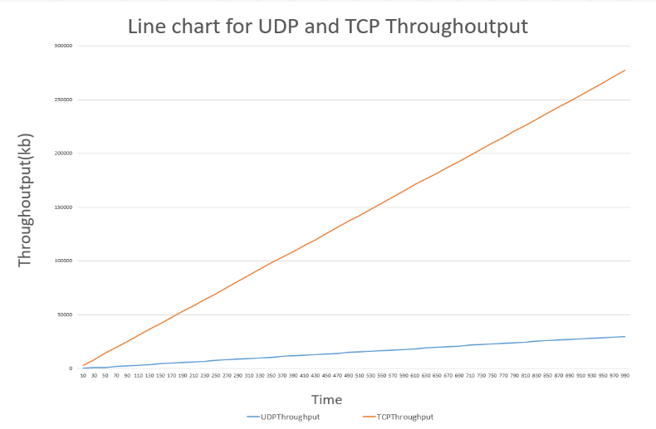From the third graph, we can observe the following: The blue line represents UDP throughput, which remains relatively stable throughout the observation period. The orange line represents TCP throughput, which shows a significant upward trend from the beginning to the end of the period. Thus, we can conclude that TCP has a big superiority in throughput than UDP in this scenario.

Second, answer the questions provided in Q1.

**Delay:** The high delay in UDP may cause by network configuration and initialization or lack of congestion control. In contrast, the reason why TCP has a lower delay may be TCP uses a congestion control protocol (e. g. slow start, congestion avoidance) and TCP guarantees sequential and reliable transmission of packets, and lost packets are retransmitted. This mechanism reduces delays due to disorder or retransmission. For the reason why the delay in UDP dramatically increases at the start may attribute to network initialization processes and protocol behaviors. Which means during the early stages of the simulation, nodes may be establishing connections and adjusting, leading to fluctuating delay values. This phase is critical as it sets the groundwork for how the network manages data transmission, directly impacting the observed delays.

**Throughput:** The reason why TCP throughput is far bigger than UDP may because that UDP is a simpler, connectionless protocol designed for applications that require fast, real-time data transmission, such as streaming and gaming. It does not provide congestion control, flow control, or reliable delivery. UDP sends packets continuously without ensuring the network can handle the traffic, which can lead to packet loss in congested networks. Moreover, since UDP does not retransmit lost packets or ensure their order, the effective throughput might be lower as the receiving application may not use out-of-order or missing packets, depending on its tolerance to data loss. Thus, TCP's ability to adapt to network conditions, manage data flow efficiently, and ensure the reliability and order of packet delivery allows it to achieve higher throughput compared to UDP.

**Packet Drop:** Possible reasons for initial packet drop trends may be network stabilization or resource allocation. The reasons that cause the packet drop may be network congestion, which leads to buffer overflows at routers and switches as they cannot process incoming packets fast enough; Weak signal strength or interference in wireless networks, causing packets to be lost during transmission. The reason why TCP dominates UDP in Packet drop Ratio is that TCP is originally designed to provide a reliable data transmission mode, while UDP focuses more on providing low-latency and efficient transmission, sacrificing certain data transmission reliability.

**Conclusion**

This comprehensive study meticulously compares the performance of TCP and UDP within a simulated network environment, utilizing a circular network topology consisting of at least ten nodes. Results confirm TCP's superiority over UDP across several key performance metrics, including lower packet drop rates, virtually no delay, and significantly higher throughput stability. This study also analyzes the common reasons of packet drop, delay and high or low throughput. Future enhancements should focus on optimizing UDP's performance under variable network conditions and integrating adaptive features to improve its reliability and throughput, potentially making it more competitive with TCP in diverse scenarios.